POWER SUPPLY
The Arduino UNO operates using an ATmega328P microcontroller, which requires a regulated 5V DC supply. The board, however, is designed to be flexible and can be powered in multiple ways:
- Through the USB port
- Via the external DC power jack (barrel jack)
- Using the Vin pin directly on the board
Each power input method comes with specific operational ranges and internal regulation paths to ensure the microcontroller always receives the correct voltage.

a) USB Power Supply (5V DC)
- This is the most common power source when the board is connected to a computer or a USB power adapter.
- Provides a direct 5V input regulated by the USB power source.
- Suitable for low-power applications and debugging.
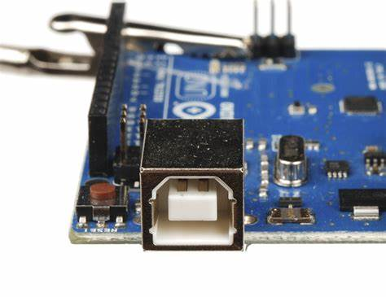
- Current is typically limited to 500 mA from a standard USB port.
Fig 5.1.1 USB Power

b) External DC Power Supply (Barrel Jack)
- The Arduino UNO includes a standard 2.1mm centre-positive barrel jack that accepts input voltages from 7V to 12V (recommended).
- Internally, the board uses a linear voltage regulator (such as the NCP1117) to step this voltage down to 5V.
- Useful for standalone applications or where USB power is not available.
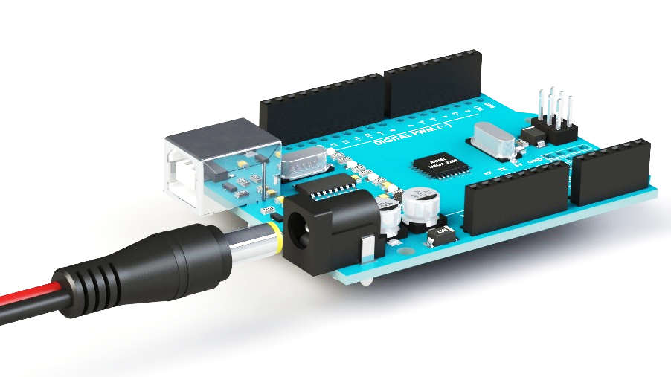
- Can typically provide more current than USB alone.
Fig 5.1.2 External DC Power
c) Vin Pin
- An alternate method to power the board is to supply 7V to 12V directly to the Vin pin.
- This voltage is regulated down by the same onboard linear regulator.
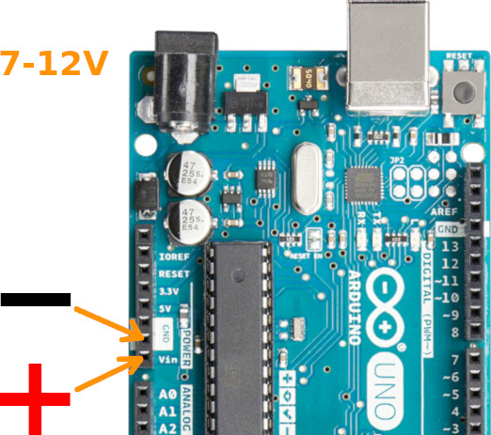
- Often used when integrating the Arduino into custom power circuits.
Fig 5.1.3 Vin Pin
Onboard Voltage Regulation
The Arduino UNO features a built-in voltage regulator to ensure stable 5V operation regardless of minor fluctuations in input voltage. The regulator typically used is:
- NCP1117 (Low Dropout Linear Regulator)
  - Input Voltage Range: 7V–12V
  - Output Voltage: 5V
  - Output Current Capacity: Up to 800 mA
  - Features: Thermal overload protection, short circuit protection, and low dropout voltage
This regulator ensures that even if there are small surges or drops in the input voltage, the microcontroller and connected components will continue to operate reliably.

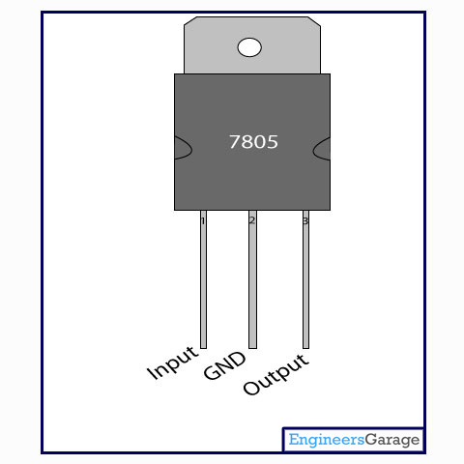
Voltage Regulator
Fig 5.1.4 Varactor Diode
The IC 7805 is a type of voltage regulator that provides a fixed 5V DC output from a higher voltage input, typically between 7V and 12V. It is part of the 78xx series of regulators and is widely used in electronic circuits to power 5V devices like microcontrollers, sensors, and modules. The IC has three pins: input, ground, and output. It also includes built-in features like thermal overload protection, short-circuit protection, and voltage regulation, ensuring a stable and reliable 5V supply.

5.2 ARDUINO UNO MICROCONTROLLER
The Arduino UNO is one of the most popular and beginner-friendly microcontroller development boards in the world of embedded systems and electronics. It is widely used in academic, hobbyist, and industrial projects due to its simplicity, open-source hardware design, and extensive community support.
Overview
The Arduino UNO is based on the ATmega328P microcontroller developed by Atmel (now part of Microchip). It offers a simple platform for building digital devices that can sense, control, and interact with the physical world.
- Microcontroller: ATmega328P
- Operating Voltage: 5V
- Input Voltage (recommended): 7V – 12V
- Digital I/O Pins: 14 (of which 6 can provide PWM output)
- Analog Input Pins: 6
- DC Current per I/O Pin: 20 mA
- Flash Memory: 32 KB (0.5 KB used by bootloader)
- SRAM: 2 KB
- EEPROM: 1 KB
- Clock Speed: 16 MHz
Key Components
- USB Port: Used to connect the Arduino to a PC for programming and communication.
- Power Jack: For powering the board through an external power supply (7V–12V recommended).
- Reset Button: Resets the microcontroller; useful for restarting the program.
- Voltage Regulator: Converts input voltage to a steady 5V for the microcontroller.
- Crystal Oscillator (16 MHz): Provides the clock signal required for timing functions.
- Digital I/O Pins: Used for interfacing with digital components like LEDs, motors, and sensors.
- Analog Input Pins: Used for reading analog signals like temperature, light, or pressure.
- ICSP Header: For programming the microcontroller directly using an external programmer.
- TX/RX LEDs: Indicate data transmission (TX) and reception (RX) over USB.
Programming and Software
Arduino UNO is programmed using the Arduino IDE (Integrated Development Environment), which uses a simplified version of C/C++. The board connects to the computer via USB, and code (called a sketch) is uploaded using the bootloader already present on the ATmega328P.
The Arduino platform supports a wide range of libraries and example codes, making it easy to interface with components like sensors, displays, motors, and wireless modules.
Applications
- IoT (Internet of Things) Prototypes
- Home Automation
- Robotics
- Environmental Monitoring
- Educational Kits
- Sensor-Based Projects
- Wireless Communication (with Wi-Fi/Bluetooth modules)
Advantages
- Easy to use and beginner-friendly
- Wide availability and low cost
- Strong community support and open-source hardware
- Supports rapid prototyping
- Compatible with numerous sensors and modules
Limitations
- Limited memory and processing power for large or complex tasks
- Not suitable for real-time or high-speed processing
- Not ideal for industrial-grade or long-term embedded systems without external enhancements.

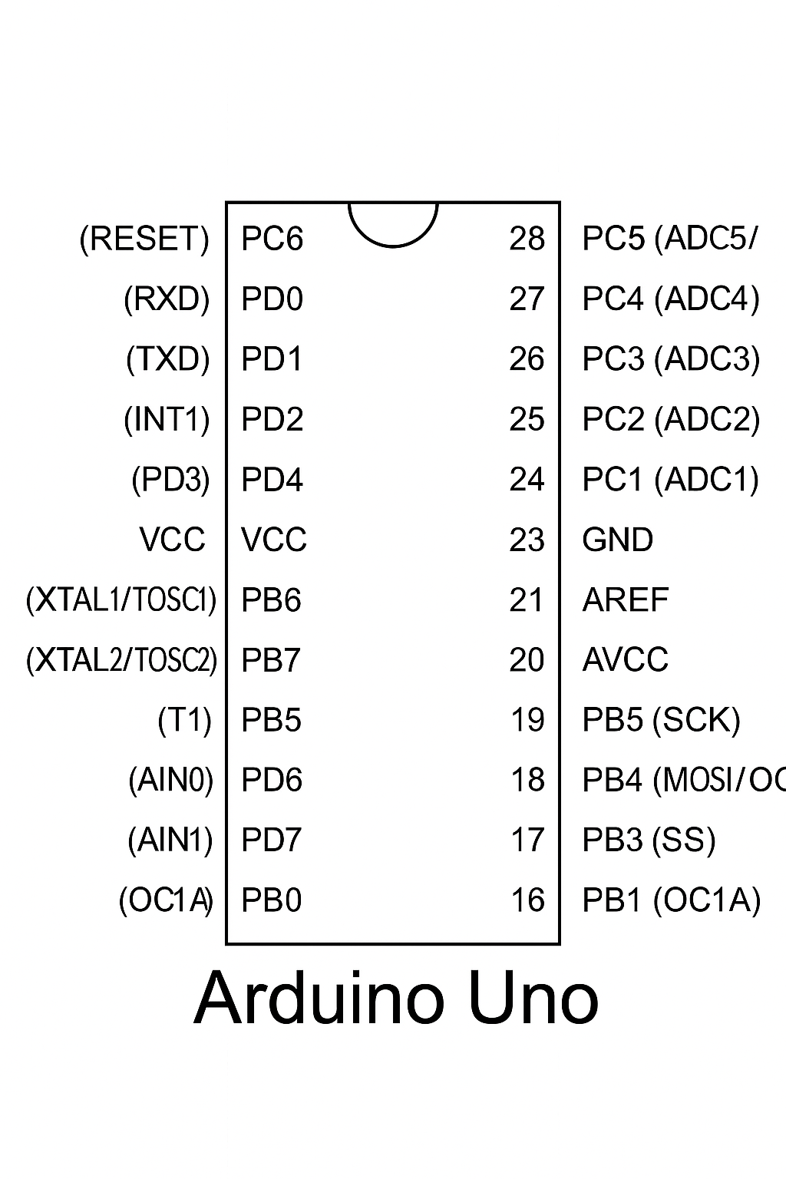
5.2.1 PIN DIAGRAM

Fig 5.2.1 PIN Diagram of ARDUINO UNO

5.2.2 PIN CONFIGURATION OF ARDUINO
Pin Number | Pin Name | Description
0 | RX | Serial receive pin (UART communication)
1 | TX | Serial transmit pin (UART communication)
2 | Digital Pin 2 | Digital I/O pin
3 | Digital Pin 3 (PWM) | Digital I/O with PWM output
4 | Digital Pin 4 | Digital I/O pin
5 | Digital Pin 5 (PWM) | Digital I/O with PWM output
6 | Digital Pin 6 (PWM) | Digital I/O with PWM output
7 | Digital Pin 7 | Digital I/O pin
8 | Digital Pin 8 | Digital I/O pin
9 | Digital Pin 9 (PWM) | Digital I/O with PWM output
10 | Digital Pin 10 (PWM) | Digital I/O with PWM output (also SPI SS)
11 | Digital Pin 11 (PWM) | Digital I/O with PWM output (also SPI MOSI)
12 | Digital Pin 12 | Digital I/O pin (also SPI MISO)
13 | Digital Pin 13 | Digital I/O pin (built-in LED, SPI SCK)
A0 | Analog Pin A0 | Analog input pin (also digital I/O)
A1 | Analog Pin A1 | Analog input pin (also digital I/O)
A2 | Analog Pin A2 | Analog input pin (also digital I/O)
A3 | Analog Pin A3 | Analog input pin (also digital I/O)
A4 | Analog Pin A4 (SDA) | Analog input / I2C data line
A5 | Analog Pin A5 (SCL) | Analog input / I2C clock line
- | VIN | External voltage input (7V–12V recommended)
- | 5V | Regulated 5V output
- | 3.3V | Regulated 3.3V output
- | GND | Ground (multiple pins available)
- | RESET | Reset pin (manual or external reset)
- | IOREF | Voltage reference for shields
- | AREF | Analog reference voltage for ADC

Table 5.2.2 PIN CONFIGURATION OF ARDUINO

5.2.3 FEATURES OF ARDUINO UNO
- Based on the ATmega328P microcontroller.
- Operates at 5V logic level.
- 14 digital I/O pins (6 with PWM capability).
- 6 analog input pins.
- Clock speed: 16 MHz
- Built-in USB interface for easy programming.
- Onboard LED on digital pin 13.
- 32 KB flash memory, 2 KB SRAM, and 1 KB EEPROM.
- Reset button and power jack available.
- Compatible with Arduino IDE for programming.
5.2.4 PERIPHERAL FEATURES
- PWM outputs (Pulse Width Modulation) for analog-like control.
- UART (Serial Communication) via pins 0 and 1.
- SPI communication (pins 10, 11, 12, 13).
- I2C communication (pins A4 - SDA, A5 - SCL).
- External and internal interrupts (INT0, INT1 on digital pins 2, 3).
- ADC (Analog to Digital Converter) with 10-bit resolution on analog pins.

5.2.5 SPECIAL FEATURES
- Watchdog Timer to prevent system lockup.
- Sleep modes for power saving.
- External and internal oscillator support.
- Bootloader pre-installed (allows code upload via USB).
- Brown-out detection to prevent unstable operation.
CMOS Technology
- Low power consumption due to CMOS (Complementary Metal-Oxide-Semiconductor) technology.
- High noise immunity and efficient thermal performance.
- Ideal for battery-powered and embedded applications.
I/O and Packages
- I/O lines: 23 programmable I/O lines available.
- Dual in-line package (DIP) and Surface-mount package (SMD) available.
- Standard female header pins for easy prototyping.
- IOREF pin to support different shield voltage levels.

5.2.6 DETAILED FEATURES OF ARDUINO UNO
CATEGORY | FEATURE
Microcontroller | ATmega328P
Operating Voltage | 5V
Input Voltage (Recommended) | 7V – 12V
Input Voltage (Limits) | 6V – 20V
Digital I/O Pins | 14 (6 of them support PWM output)
PWM Channels | 6 (Digital pins: 3, 5, 6, 9, 10, 11)
Analog Input Pins | 6 (A0 to A5)
DC Current per I/O Pin | 20 mA
DC Current for 3.3V Pin | 50 mA
Flash Memory | 32 KB (0.5 KB used by bootloader)
SRAM | 2 KB (ATmega328P)
EEPROM | 1 KB (ATmega328P)
Clock Speed | 16 MHz
USB Interface | Yes (USB-B port for programming & communication)
Power Connector | Barrel jack (for external power source)
On-board LED | Yes (connected to Digital Pin 13)
Serial Communication | UART (Pins 0 – RX, 1 – TX)
SPI Interface | Pins 10 (SS), 11 (MOSI), 12 (MISO), 13 (SCK)
I2C Interface | Pins A4 (SDA), A5 (SCL)
Reset Button | Yes (manual reset capability)
ICSP Header | Yes (In-Circuit Serial Programming support)
Bootloader | Pre-installed to allow USB programming
Voltage Regulator | On-board regulator for stable 5V and 3.3V output
Technology | Built using CMOS (low power, high efficiency)
Form Factor | Standard Arduino UNO layout (compatible with shields)
I/O Ports Packaging | Female header pins (DIP & SMD versions available)
Special Features | Brown-out detector, Watchdog timer, multiple sleep modes for power saving

Table 5.2.6 DETAILED FEATURES OF ARDUINO UNO

5.2.7 SPECIAL FUNCTION REGISTERS
Arduino UNO uses an ATmega328P microcontroller, which includes several Special Function Registers (SFRs) to control hardware at a low level.
Port Control Registers
These include DDRx, PORTx, and PINx. They control the data direction (input/output), write logic levels to digital pins, and read input values.
Timer/Counter Registers
Registers like TCCRn, TCNTn, and OCRn configure timers for generating delays, PWM signals, and measuring time intervals.
Interrupt Registers
Registers such as EIMSK, EIFR, and PCICR are used to manage and trigger hardware interrupts based on external events or pin changes.

ADC Control Registers
Registers like ADMUX, ADCSRA, ADCL, and ADCH manage analog-to-digital conversion for reading analog sensors using analogRead ().
USART Registers
Registers including UBRR0, UCSR0A/B/C, and UDR0 manage serial communication (UART) for sending and receiving data through the Serial interface.
Status and Control Registers
SREG holds status flags like carry and zero; MCUCR manages sleep and reset behaviour; SPCR controls SPI communication settings.

5.2.8 PROGRAMMING IN ARDUINO UNO
Programming an Arduino microcontroller, such as the Arduino UNO based on the ATmega328P chip, is done using the Arduino Programming Language, which is a simplified form of C/C++. The development process takes place in the Arduino IDE (Integrated Development Environment), a user-friendly platform that includes a code editor, built-in compiler, and uploader. Every Arduino program, or sketch, contains two main functions: setup (), which runs once for initialization, and loop (), which executes repeatedly to control hardware behaviour. Code is uploaded to the board via USB, using the onboard bootloader. Arduino supports multiple communication protocols like UART, SPI, and I2C, enabling it to interface with a variety of external components. The use of libraries (added via #include) simplifies coding for tasks like controlling displays or reading sensors. Developers can also monitor and debug programs in real-time using the Serial Monitor with commands like Serial. Print (). Overall, Arduino programming is accessible, well-supported, and powerful for a wide range of electronics projects.

Components associate with ARDUINO
Arduino board, breadboard, jumper wires, resistors, LEDs, push buttons, potentiometers, sensors (temperature, light, ultrasonic, motion), servo/DC motors, motor drivers, LCD/OLED displays, relays, buzzers, power modules, and communication modules (Wi-Fi, Bluetooth).

Applications
- Multiple DIY projects
- Projects requiring multiple I/O interfaces and communications
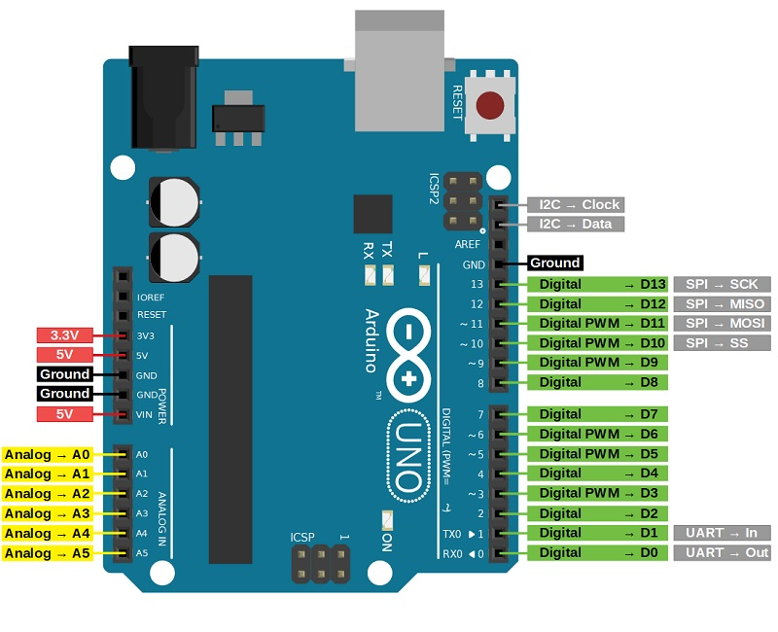
- Ideal for advanced-level A/D applications in automotive, industrial appliances, and consumer electronics.
Fig 5.2 ARDUINO MICROCONTROLLER

Abbreviation | Full Form
IRS | Intelligent Reflecting Surface
MIMO | Multiple Input Multiple Output
IoT | Internet of Things
NLOS | Non-Line-Of-Sight
SNR | Signal-to-Noise Ratio
FPGA | Field-Programmable Gate Array
RF | Radio Frequency
WSN | Wireless Sensor Network
CSI | Channel State Information
AI | Artificial Intelligence
ML | Machine Learning
WPCN | Wireless Powered Communication Network
CRB | Cramér–Rao Bound
ISWPT | Integrated Sensing and Wireless Power Transfer
SDP | Semi-Definite Programming
LC | Low Complexity
SCA | Successive Convex Approximation
MM | Majorization-Minimization
CVX | Convex Optimization Toolbox (MATLAB)
HAP | High-Altitude Platform
WD | Wireless Devices
AR/VR | Augmented Reality / Virtual Reality
FEA | Finite Element Analysis
CAD | Computer-Aided Design
GUI | Graphical User Interface
EMC | Electromagnetic Compatibility
FSI | Fluid-Structure Interaction
MEMS | Micro-Electromechanical Systems
SISO | Single Input Single Output
OFDM | Orthogonal Frequency Division Multiplexing
URLLC | Ultra-Reliable Low-Latency Communication
5G NR | 5G New Radio
Wi-Fi | Wireless Fidelity
AM | Amplitude Modulation
FM | Frequency Modulation
PSK | Phase Shift Keying
FSK | Frequency Shift Keying
APES | Amplitude and Phase Estimation
COMSOL | COMSOL Multiphysics Software
CST | CST Microwave Studio
S11 | Reflection Coefficient (Scattering Parameter S11)
n traditional Wireless Sensor Networks (WSNs), data transmission systems often suffer from limitations that affect performance and reliability. These networks, made up of multiple sensor nodes, are used to monitor environmental parameters but face challenges like interference, fading, and signal blockage—especially in urban or remote areas. Multipath fading caused by obstacles can distort signals and cause delays.
Conventional WSNs also have restricted data rates and low spectral efficiency due to limited bandwidth and basic communication protocols. Most sensor nodes operate on low power, which limits their ability to handle high data traffic or real-time applications. Battery limitations and energy waste through retransmissions or idle listening further reduce network lifespan.
Moreover, WSNs lack adaptability to changing conditions, as they often cannot reconfigure intelligently or optimize transmission. These drawbacks impact accuracy, increase latency, and reduce scalability in larger or mission-critical deployments.
0

The proposed system integrates Multiple-Input Multiple-Output (MIMO) antenna-equipped sensor nodes within a wireless network, strategically distributed to monitor and optimize signal transmission in challenging environments. These nodes are capable of measuring signal strength, Channel State Information (CSI), and interference patterns in real time. Additionally, RF sensors are deployed to collect detailed data on multipath propagation, fading conditions, and other environmental effects that typically degrade signal quality.
To counteract these impairments, the system leverages advanced signal processing techniques such as beamforming and precoding, which allow for directed signal transmission, reducing interference and improving reliability. Machine learning models are incorporated to detect, classify, and mitigate interference dynamically. Furthermore, the system enables the real-time adjustment of antenna parameters, allowing it to respond adaptively to environmental changes and optimize communication paths for improved network efficiency.
This intelligent, adaptive architecture represents a significant step toward next-generation wireless networks, offering enhanced performance, reliability, and energy efficiency.

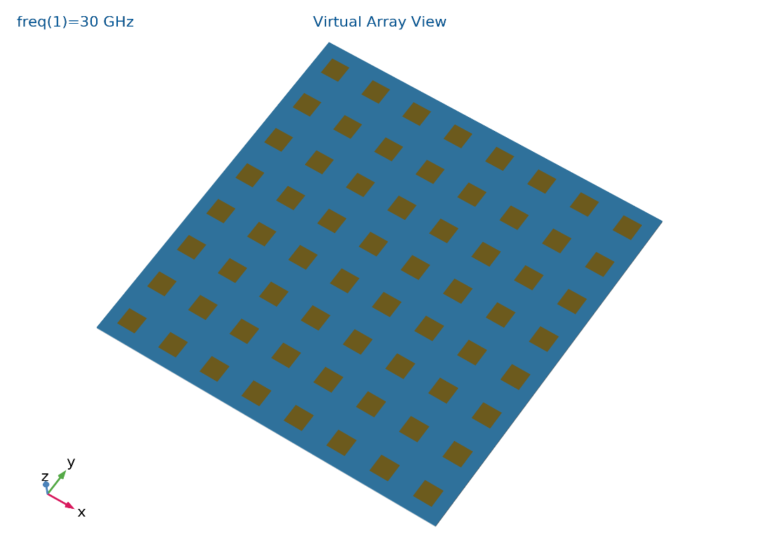
The Intelligent Reflecting Surface (IRS) is a passive meta surface technology that enhances wireless communication by dynamically controlling the reflection and direction of electromagnetic waves. Unlike active elements such as RF amplifiers, IRS does not generate or amplify signals—it simply manipulates the propagation of incident waves to optimize performance in wireless networks like 5G and future 6G systems.
Fig 7.1 IRS PANEL
7.1.1 Architecture and Components
The IRS system consists of the following key components:
- Meta surface Panel: The core structure of the IRS is a passive reflective array made of reconfigurable unit cells. Each unit cell adjusts its reflection phase using electronic tuning elements like PIN diodes or liquid crystal materials to control wave redirection.
- Control Mechanism: The IRS operates under external control from network processors or base stations. These controllers send configuration signals to modify the phase response of each unit cell.
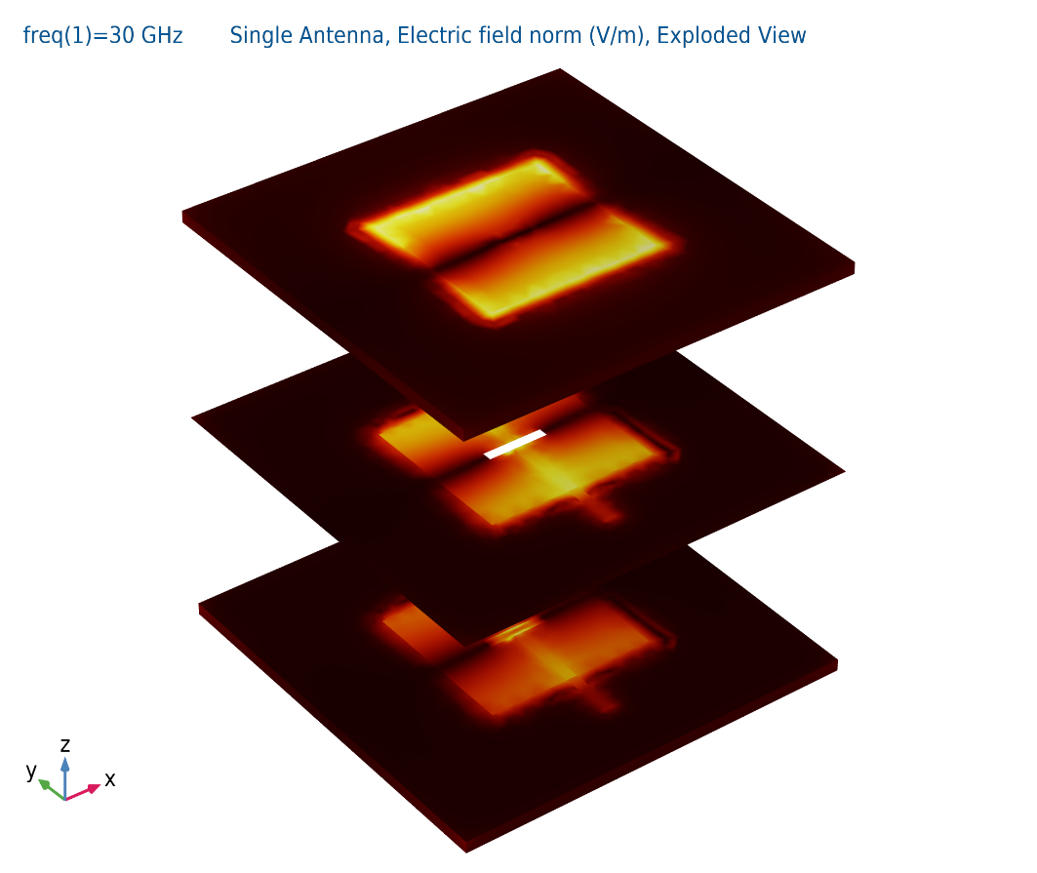
- Wave Manipulation Strategy: The system alters electromagnetic wave behaviour using programmable reflection, enabling beam steering, interference suppression, and improved signal coverage.
Fig 7.1.1 Single Element Exploded View

7.1.2 Passive Beamforming Techniques
Since IRS does not actively amplify signals, its function relies on passive beamforming, where incident signals are redirected efficiently to target locations. This is achieved through:
- Phase Shifting: Each IRS unit cell modifies the phase of incoming waves to optimize reflection angles.
- Constructive Interference Engineering: Signals are redirected in such a way that they reinforce intended transmission paths, improving overall network signal strength.
- Polarization Adjustment: IRS elements can manipulate signal polarization to match the receiver’s antenna characteristics.

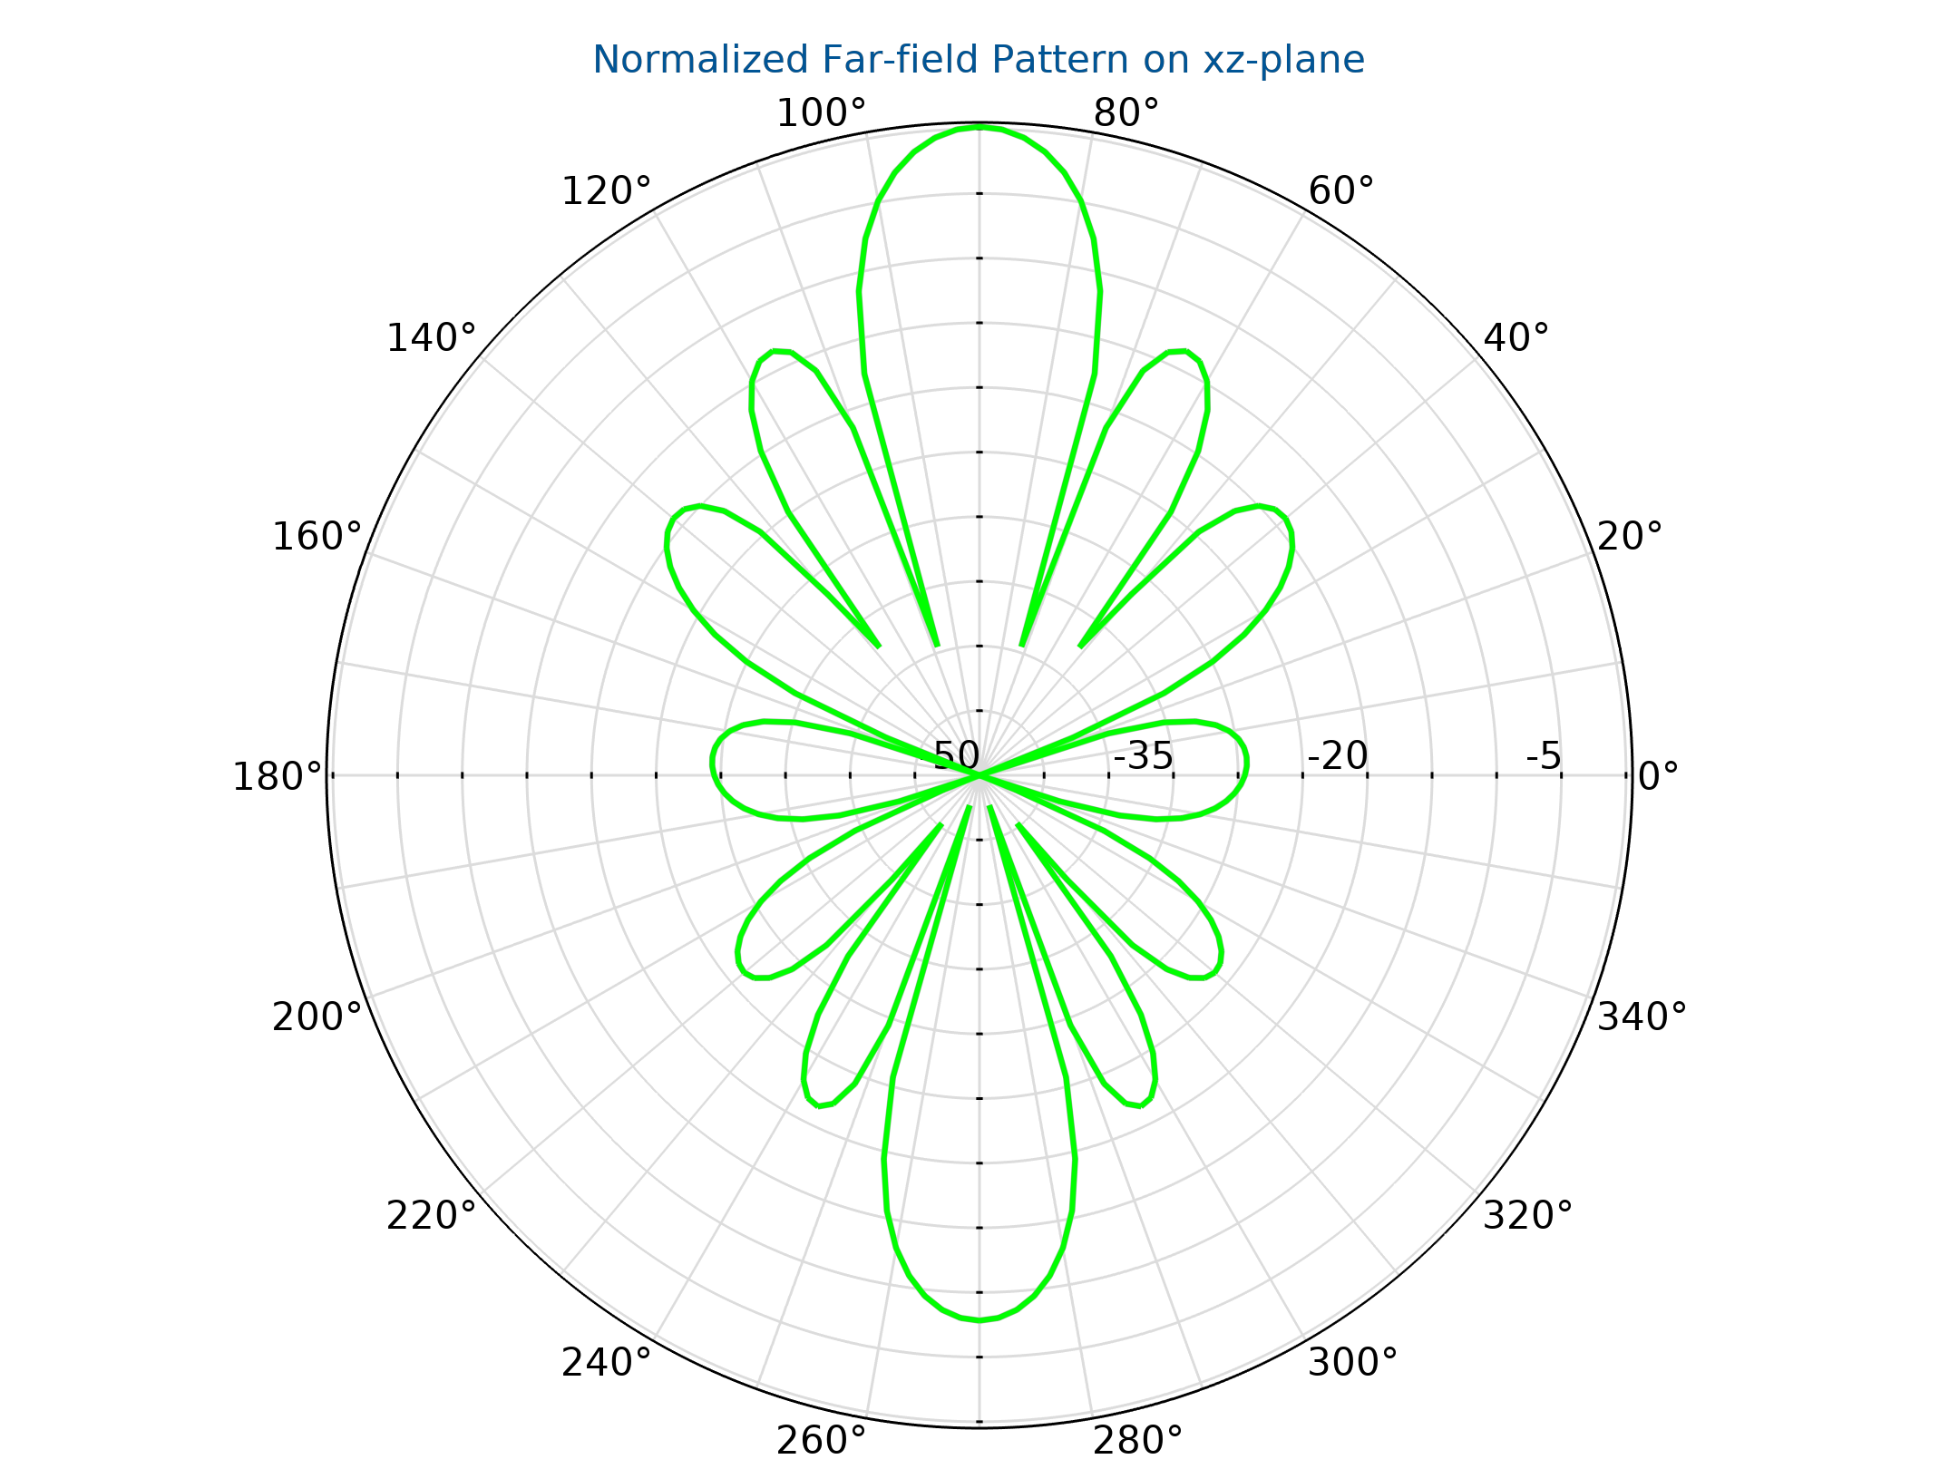
Fig 7.1.2 Radiation Pattern of the IRS

7.1.3 Deployment and Network Optimization
IRS panels are installed at strategic locations to improve network reliability and coverage without requiring additional power sources. Common deployment scenarios include:
- Building-mounted IRS: Enhances signal propagation in dense urban environments.
- Indoor IRS Arrays: Improves communication in offices, conference rooms, and enclosed spaces.
- Vehicular IRS Solutions: Increases mobile network stability by optimizing reflections for moving receivers.

7.1.4 Computational Modelling & Performance Evaluation
To validate IRS efficiency, simulations are performed using COMSOL Multiphysics, MATLAB, or CST Microwave Studio. Key evaluation metrics include:
- S-Parameter Analysis (S11): Measures reflection properties and impedance matching.
- Radiation Pattern Simulation: Determines how well IRS redirects signals in different directions.
- Energy Efficiency Assessment: Since IRS is passive, power consumption is minimal, making it ideal for low-energy, high-performance communication networks.

The Intelligent Reflecting Surface (IRS)-assisted MIMO wireless communication system is implemented by integrating both hardware and software components to optimize wireless signal propagation. The IRS panel is designed and simulated in COMSOL Multiphysics 6.3, where the unit cell structure, material properties, and electromagnetic behavior are modeled using full-wave simulations. COMSOL enables the detailed analysis of phase shifting, signal reflection, and beamforming capabilities of the IRS elements under different frequencies and environmental conditions. The simulation outputs, such as S-parameters, radiation patterns, and phase responses, guide the physical design of the IRS panel, ensuring accurate control over signal manipulation in real-world scenarios.
Once the IRS hardware model is validated in COMSOL, the MATLAB software is employed for signal processing, phase shift optimization, and performance evaluation of the IRS-assisted MIMO system. MATLAB scripts simulate the control algorithms that configure the IRS phase shifts in real-time based on Channel State Information (CSI) and user locations. The polar plots of IRS phase shifts demonstrate the capability to steer reflected beams by dynamically adjusting phase values across the surface.
The MATLAB simulation outputs also include SNR comparison plots, which reveal a significant improvement in Signal-to-Noise Ratio when IRS is used, confirming the system’s ability to enhance signal quality in challenging Non-Line-of-Sight (NLOS) environments. Furthermore, the incident power distribution across IRS elements and the power contribution plots highlight how the IRS efficiently manipulates signal energy, while the magnitude of the reflected channel gain validates the beamforming effectiveness.

